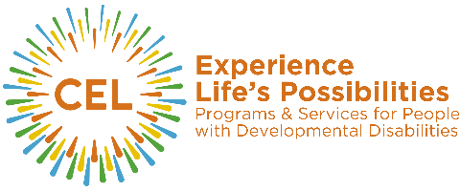

Gifts of Securities via DTC Wire Transfer

Thank you for your gift of securities in support of the Center for Enriched Living. We are delighted to have you as a partner in our efforts to empower people with intellectual and developmental disabilities and remain grateful for your generous support.

We ask that you complete the form below and forward to your financial advisor for execution. Please also contact Lisette Zaid, Director of Development, Lisette@ExperienceCEL.org or 847.315.9919 to notify us of your pending gift; this will assist us in properly recording and acknowledging your contribution.

To (Financial Advisor of Donor): _______________________________________________________________

Telephone: ______________________ Fax: ___________________________

Please use this form as authorization to transfer the securities listed below from my account to RW Baird to serve as a charitable contribution to the Center for Enriched Living.

Donor Name:
Donor Address:
Telephone: |  | Email:
Name of Security: |  | Number of Shares:
Signature:

DTC WIRING INSTRUCTIONS FOR FINANCIAL ADVISORS
For securities and mutual fund gifts to the Center for Enriched Living, please deliver by DTC to:
RW Baird
DTC Participant Number: 0547
Account Name: CEL
Account Number: 70242522

For assistance, please contact Paiten Grosvenor
Phone: (312) 332-5656
Email: PGrosvenor@RWBaird.com

Please note Donor’s name and address along with the name of security and number of shares.

To aid in properly crediting this gift to your client, we ask that you please contact Lisette Zaid, Director of Development, Center for Enriched Living (Lisette@ExperienceCEL.org 847.315.9919) and notify us of your client’s intent to donate securities.

